- Five Room House puzzle (Write a program using NetworkX)
The object of the puzzle is to draw a continuous path through the walls of all 5 rooms, without going through any wall twice, and without crossing any path.

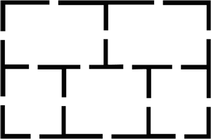

- Knight Tours (Write a program using NetworkX) Is it possible for a knight on a chessboard to visit every square once and exactly once?
- Robotic Path Planning (Write a program using NetworkX)
